Technology as a way to achieve quality education within a quantum physics course
Eirini-Sofia Mavrogiorgou - emayrogiorgou@athenscollege.edu.gr
Hellenic American Educational Foundation – Athens College
Christos Papanikolaou – cpapanikolaou@athenscollege.edu.gr - Physicist
Summary
The double-slit experiment is a demonstrates the wave nature of light and particles through interference patterns. This paper aims to provide a study and a digital analysis model of the experiment. This will be achieved through a brief theoretical overview of the principles of the double slit experiment. Furthermore, the double slit experiment will be performed and the measurements collected will be presented. These measurements will be used to analyze the resulting interference patterns through a python-based computational model. Finally, this project contributes to Sustainable Development Goal 4 (Quality Education) as a digital tool for learning is created.
Keywords: Quantum physics, Double-slit experiment, Fringe spacing, Experimental data analysis software, Sustainable Development Goal 4 (Quality Education)
Introduction
Scientist Richard Feynman once said, “I think I can safely say that nobody understands quantum mechanics” [7], a statement that highlights how difficult quantum physics is to comprehend. Many of its concepts go against common sense, which makes them hard to teach and learn using traditional educational methods. Sustainable Development Goal 4 (Quality Education), one of the 17 SDGs, that are a “universal call for action to ensure that by 2030 people will enjoy peace and prosperity” [8] focuses on improving learning for all students, including in science. To be more specific, using digital tools can help make difficult topics easier to understand, as it allows them to explore abstract ideas.
Quantum Physics studies matter and energy at its most fundamental level. It is laws that describe the behavior of systems that might consist of electrons, atoms, molecules, crystals. At the microscopic scale, less than the size of an atom, the classical laws of Newtonian mechanics are no longer applicable. [1,2] This is where quantum physics steps in. Not only did it help us understand the world of particles, photons and electrons, but led to the development of modern devices, such as lasers, transistors and electron microscopes. Most importantly, it showed that particles can also behave as waves. [3]
This dual wave-particle nature of matter was first demonstrated in 1801 by Thomas Young’s double-slit experiment, which showed that light produces an interference pattern. This is shown in figure 1 (Appendix). In 1905, Einstein defined light as quanta, confirmed by Millikan in 1914. Furthermore, in 1924 Louis de Broglie suggested that particles behave as waves, proven in 1927 by Davisson and Germer. [10] It is therefore evident that systematic research to prove the wave-particle duality of light underscores that the nature of quantum objects remains unresolved.
The double-slit experiment involves a source of light or particles directed toward a barrier, containing two narrow slits. A detection screen is placed beyond the barrier. The slits, as coherent sources of light, create a pattern of light and dark fringes. [5] This pattern reveals constructive and destructive interference; two waves overlap in such a way that they either combine to create a larger wave or cancel each other out. [5,6]
Our Double-slit experiment
Materials - Methods
In order to develop a software collecting and analyzing data, performing the double-slit experiment beforehand was essential. For this purpose, a monochromatic source (red and green laser pointers), a double slit apparatus with slit separation d=0.176 mm, millimeter graph paper and ruler to measure fringe positions were needed. Moreover, the experiment was conducted in low-light environment for the fringes to be visible on the screen. The experiment setup is shown in figure 2 (Appendix).
A measuring tape was also used in order to find the total distance from the light source-laser pointer to the screen. In this experiment, this distance D was equal to 389,7 cm. The wavelength of light λ was known too. λ(green) ≈ 530nm and λ(red) ≈ 650 nm. This experiment explored the differences between the red and green laser pointer wavelength and more specifically how it might affect the resulting interference pattern in each case.
Before conducting the experiment and in order for my observations to be valid, calibration was important. For this purpose, we checked the temporal and spatial coherence of each light source. Temporal coherence was checked by gradually increasing the optical path difference (moving the screen farther from the slits). If interference fringes began to fade or disappear before the screen reached a certain distance Lc (coherence length), the light source wouldn’t be appropriate. On the other hand, spatial coherence is tested through observing single slit diffraction and opening both slits afterwards. If no interference pattern was observed, it would mean that the laser didn’t illuminate the slits appropriately.
After noting the beginnings and ends of the fringes in a millimeter paper for each laser, the average fringe spacing between every two bright fringes (6 in total) was measured. In order to achieve this, the fringe spacing formula was used:
$$Δx=\frac{λ⋅L}{d}$$
Results
Finally, the difference between the average fringe spacing Δx for each laser is visible. Δx(red) ≈ 4,9mm while Δx(green) ≈ 3,8mm. The measurements collected helped test and improve the program created.
Data analysis software
Materials - Methods
The data analysis software created is a user-friendly python script developed in google colab. Through it one can calculate any variable’s value from the formula mentioned above. It is also possible to calculate the fringe spacing by importing an image of the interference pattern. If an image is imported, it is possible for the program to generate a “Double slit interference pattern” graph which contains a normal and smoothened curve and showcases the interference intensity for every pixel position.
Discussion – Future Plans
After having created a more basic program that achieves the above, the goal is to finish a web-app version of the software, something that is already being worked on. It is really important for it to be accessible by schools, universities and students as it can provide a better understanding of the principles of the experiment. The backend development of the web application is currently being created with FastAPI while the frontend with React, in JavaScript. The current program as well as the web application that is being created is/will be published at: https://github.com/s0fm4v/Double-slit-Calculator (GitHub)
Conclusion
To conclude, technology is certainly a means to achieve quality education in every sector, especially within a quantum physics course, where it becomes essential. This can be accomplished through the use of a program calculating variables and generating graphs that are shown to the user through a simple and useful environment.
Bibliographic sources
[1] Odot, L. (2025, October 17). Quantum Physics explained by A nobel prize winner. Polytechnique Insights. https://www.polytechnique-insights.com/en/columns/science/quantum-physics-explained-by-one-of-its-nobel-prize-laureat/
[2] Caltech. (2025). What Is Quantum Physics? Caltech Science Exchange. https://scienceexchange.caltech.edu/topics/quantum-science-explained/quantum-physics
[3] U.S. Department of Energy. (2025). DOE Explains...Quantum Mechanics. Energy.gov. https://www.energy.gov/science/doe-explainsquantum-mechanics
[4] LibreTexts. (2016, July 24). 27.3: Young’s Double Slit Experiment. Physics LibreTexts. https://phys.libretexts.org/Bookshelves/College_Physics/College_Physics_1e_(OpenStax)/27%3A_Wave_Optics/27.03%3A_Youngs_Double_Slit_Experiment
‌[5] Thomas, J. I. (2020). The classical double slit experiment–a study of the distribution of interference fringes formed on distant screens of varied shapes. European Journal of Physics, 41(5), 055305. https://doi.org/10.1088/1361-6404/ab9afd
‌[6] Khan Academy. (n.d.). Constructive and Destructive interference (video). Khan Academy. https://www.khanacademy.org/science/physics/mechanical-waves-and-sound/standing-waves/v/constructive-and-destructive-interference
‌[7] Himes, J. (2023, June 13). 5 Tips for Writing Quantum Technology Content | Dynamic Tech Media. Dynamic Tech Media. https://dynamictechmedia.com/5-tips-for-writing-quantum/
[8] UNDP. (2025). Sustainable development goals. United Nations Development Programme; United Nations. https://www.undp.org/sustainable-development-goals
[9] Double Slit Experiment Test Young Light Stock Vector (Royalty Free) 2063012951 | Shutterstock. (2021). Shutterstock. https://www.shutterstock.com/image-vector/double-slit-experiment-test-young-light-2063012951
‌ [10] Peng, H. (2021). Experimental Study of Mystery of Double Slit --- Comprehensive Double Slit Experiments. International Journal of Physics, 9(2), 114–127. https://doi.org/10.12691/ijp-9-2-6
Appendix

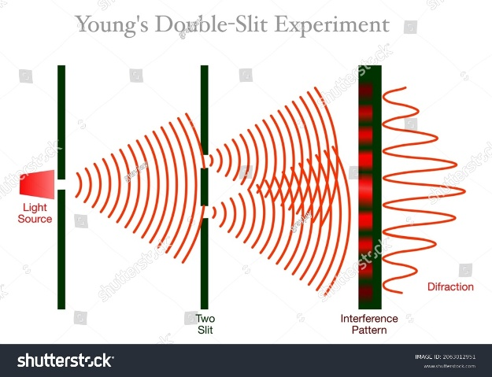
Figure 1: Photon-based double-slit experiment

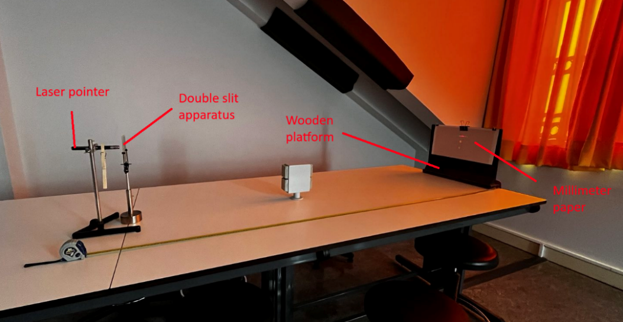
Figure 2: Experiment setup

